YEAR 11 GENERAL HUMAN BIOLOGY

Task 7: Digestive and Excretory Systems

DO NOT MARK THIS BOOKLET

Multiple Choice 10 Marks

Short Answer 20 Marks

Total 30 Marks

1. Absorption of digested food occurs largely in the:

(a) stomach.

(b) pancreas.

(c) small intestine.

(d) large intestine.

1. Urea is produced in the
2. pancreas
3. liver
4. kidney
5. skin
6. The three major parts of the kidney from the outermost layer to the innermost layer are the
7. medulla,cortex and pelvis
8. cortex,pelvis and medulla
9. medulla,pelvis and cortex
10. cortex,medulla and pelvis
11. Urine is stored in the
12. kidney
13. bladder
14. urethra
15. ureter
16. Incisor teeth are designed for
17. chewing
18. tearing
19. biting
20. grinding
21. A full set of teeth consists of
22. 36 teeth
23. 32 teeth
24. 28 teeth
25. 24 teeth
26. The series of muscular contractions that moves food along the digestive tract is called
27. periosteum
28. peristalsis
29. pericardium
30. perimysium
31. What is the function of the stomach?
32. to absorb nutrients
33. to absorb water
34. to dissolve and digest food
35. to produce solids wastes
36. Which of these is not a function of the liver?
    1. producing bile, a chemical that helps break down fats and oils
    2. storing and releasing blood sugars
    3. breaking down alcohol and other drugs
    4. absorbing nutrients and water from food
37. Which of the following is an INCORRECT pairing of “structure” and “function”?
38. Large intestines - remove water from undigested food
39. Liver receives - nutrients from the small intestine via the blood
40. Small intestine - absorbs small food molecules
41. Gall bladder - produces digestive enzymes

11.a) Label the parts of the kidney 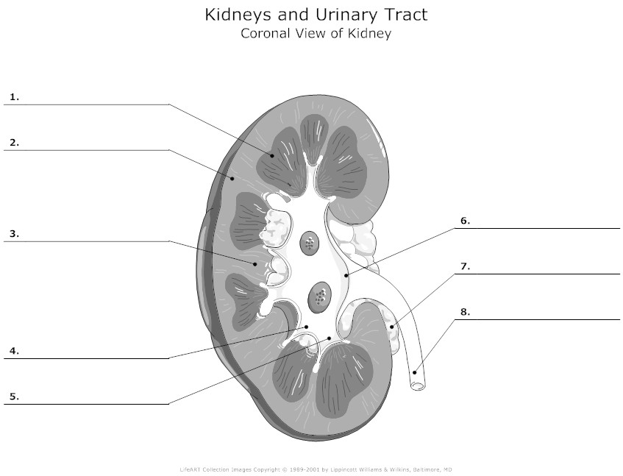

(4 marks)

1. _________________________________________
2. _________________________________________

6. _____________________________________________

7. ______________________________________________

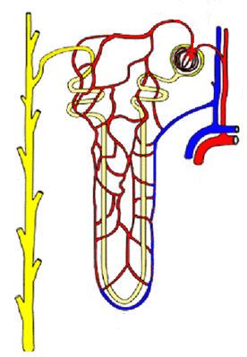

**A**

**B**

**C**

**D**

**E**

**F**

**G**

**I**

**J**

**H**

b. Label the following components (6 marks)

|  |  |  |  |
| --- | --- | --- | --- |
| A |  | E |  |
| G |  | H |  |
| D |  | I |  |

**Question 12** refers to the diagram below of the digestive tract.

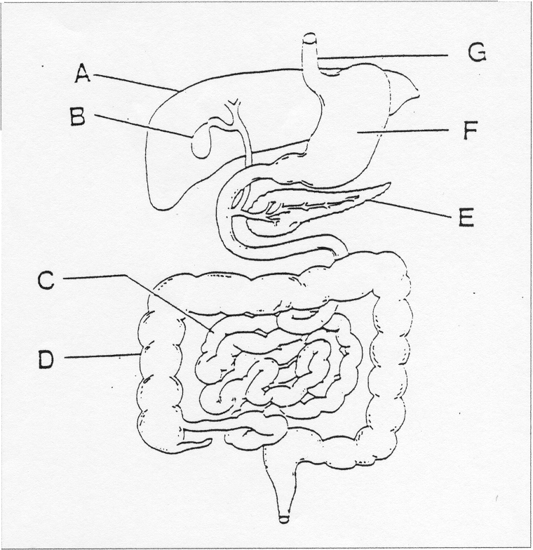

12a Complete the labels from the diagram above.

A _______________________________

B _______________________________

C _______________________________

D ________________________________

E _______________________________

F _________________________________

(6 marks)

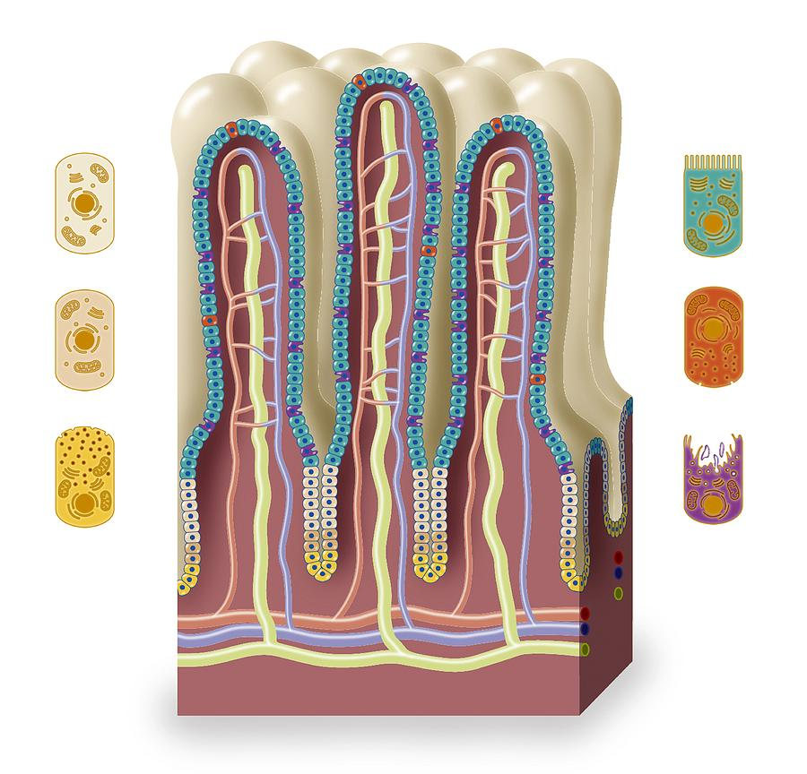

**P**

(b) (i) Identify P. _______________________________

(1 mark)

(ii) In which region of the digestive tract is P found?

(1 mark) ______________________________________________________________

(iii) Name the major function of P and explain one reasons why it is suited to this function.

(2 marks)

________________________________________________________________________________________________________________________________________________________________________________________________________________________________________________________________________­­­­­______________________________________________

**YEAR 11 GENERAL HUMAN BIOLOGY**

Test 3:

Digestive & Excretory System

SCORES:

MC: /10

SA: /20

TOTAL: /45

_______ %

**NAME:_____________________________**

**TEACHER:__________________________**

**DATE:______________________________**

**Section A: Multiple choice (10 Marks)**

Answer all questions by circling the most correct answer on the multiple choice answer sheet.

1. a b c d

2. a b c d

3. a b c d

4. a b c d

5. a b c d

6. a b c d

7. a b c d

8. a b c d

9. a b c d

10. a b c d